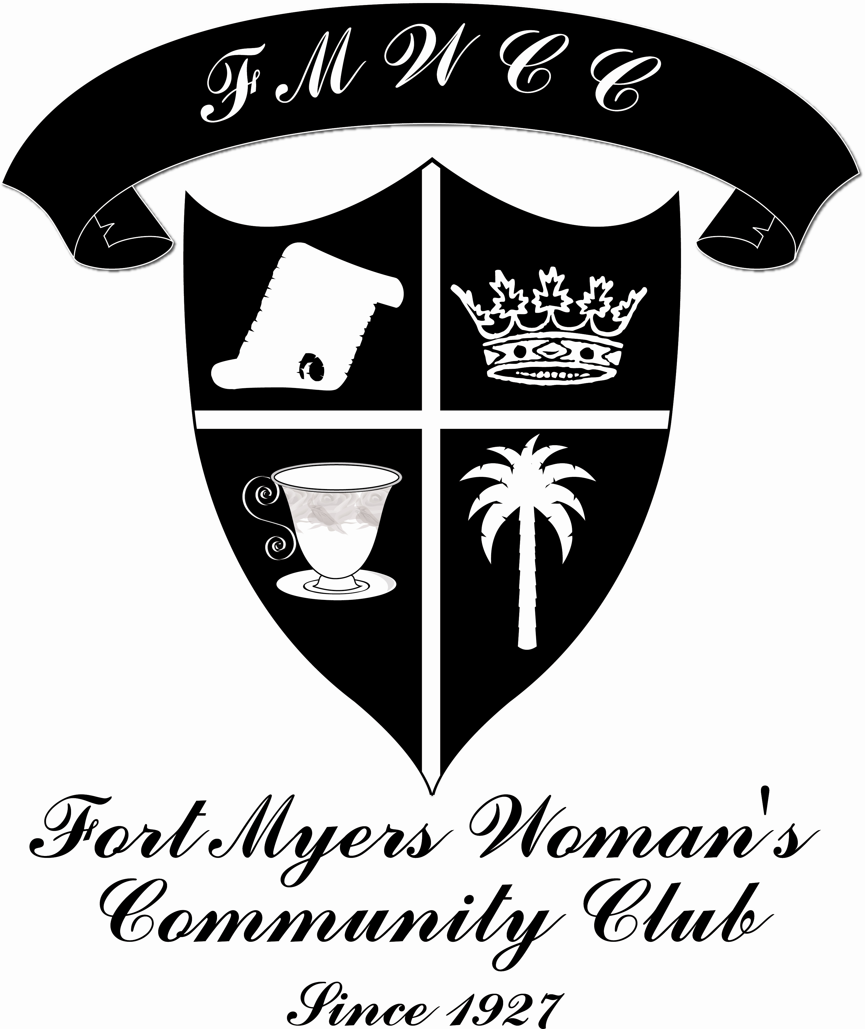

Post Office Box 62191
Fort Myers, Florida 33906
PAY DUES ONLINE at www.fmwcc.net

MEMBERSHIP APPLICATION
* Please do not complete any blanks with “same” *
Annual Membership Dues: $50 payable to FMWCC

Mrs. ___ Miss ___ Ms. ___ Dr. ___ ____________________________________________________________
First Initial/Maiden Last
Occupation _____________________________________
Spouse’s Name ___________________________ Spouse’s Occupation _________________________________
Address ____________________________________________________________________________________
____________________________________________________________________________________
Primary phone ________________________________ Alternate phone _________________________________
Email Address _______________________________ Contact you by: phone ___ email ___ text ___

Children or Grandchildren (under 25 years old) residing in Lee County
Child/Grandchild | Full Name | Gender |  | Birthdate Grade in school
___ C ___ GC |  |  | ___ F ___ M | _________ _________
___ C ___ GC |  |  | ___ F ___ M | _________ _________
___ C ___ GC |  |  | ___ F ___ M | _________ _________
___ C ___ GC |  |  | ___ F ___ M | _________ _________
Please check the committees on which you would like to serve:
COMMITTEES |  | HOLIDAY HOUSE |  |  | CORONATION |  |  | FASHION SHOW |  | TALENTS
 | Membership |  |  | Hostess |  |  | Decorations |  | Decorations |  | Computer
 | Tea Flowers |  |  | Advertising |  |  | Ballroom |  | Store Liaison |  | Calligraphy
 | Tea Food |  |  | Decorations |  |  | Foyer |  | Door Prizes |  | Musician
 | Newsletter |  |  | Grounds |  |  | Table Decoration |  | Refreshments |  | Artist
 | Website |  |  | Opening |  |  | Work with Court |  | As Needed |  | Photography
 | PR |  |  | Refreshments |  |  | Refreshments |  |  |  | Sewing
 | Outreach |  |  | As Needed |  |  | As Needed  LEADERSHIP  _____ Please check if you would be interested in pursuing a Leadership position in the FMWCC.  Membership Committee Use Only  Check #:________Cash:_____Dated:_______  Friends of FMWCC: __________  Entered by:____________________________
 | New Member Social or Mentor*
 | Properties – Table Cloths
 | House – Provide Meeting Supplies
 | As Needed

Renewal ____ Past-President _____
Membership Committee Use Only

Check# ______ Dated __________Cash ___
Entered by: __________________________
New Member ____

Helpful Information

Official Meetings take place on the 2nd Thursday of October, November, January, March, April and May.
A special Holiday House Preview Meeting takes place on the 2nd Thursday of September.
For meeting times and locations, please refer to the invitations, yearbook, Facebook page and website.
No RSVP or required dress is expected at any meeting. Just relax, bring a friend, and enjoy your time!

Section A. Duties of Standing Committees:
AUDIT. The Treasurer’s books shall be audited at the end of the fiscal year and/or at the request of the Board of Directors and Executive Committee. A written report and audited financial statement shall be submitted to the Board of Directors and Executive Committee when the audit is complete.
DEPARTMENTAL. Special functions such as Book Reviews, Art Exhibits, Flower Shows and our Club Music Department shall come under this category.
EDISON PAGEANT OF LIGHT CORONATION. This Committee shall be in charge of the Coronation ceremony.
FASHION SHOW. This committee shall be responsible for the annual fashion show.
FINANCE. This Committee shall direct the financial affairs of the club. The Treasurer of the club shall not act as chairman of this committee. The committee shall prepare a proposed budget for consideration for the ensuing fiscal year, and submit it at the final Board of Directors and Executive Committee meeting of the Club year.
HOLIDAY HOUSE. This committee shall be responsible for the annual Holiday House.
HOSPITALITY. The Hospitality chairman shall be responsible for greeters at the door for all regular meetings and special functions.
HOUSE. The House Committee shall be charged with custody of all dishes, silver, etc., and shall have the power to purchase any necessary articles for the Club use, after receiving consent of the Board of Directors or Executive Committee.
MEMBERSHIP. The Membership Committee shall be composed of a chairman, co-chairman and no fewer than five (5) members. The Membership Committee shall supply the Corresponding Secretary with a current list of members.
NOMINATING. The Nominating Committee’s duties are as listed in ARTICLE III, Section B.
PROGRAM. The First Vice-President shall be the program chairman and shall provide programs for the year. She shall make all physical arrangements for the year.
TEA COORDINATION. Tea coordinators shall secure refreshments for each meeting.
TEA TABLE DECORATIONS. This committee shall be responsible for the floral arrangements for all tables.
PROPERTIES. This committee’s duties shall include providing the table linens for each meeting and the care and storage of the Club linens.
PROMOTION AND PUBLIC RELATIONS. This committee shall promote the Club by informing the public of activities of the Club that are open to the public.
NAME TAGS. This committee shall be responsible for providing nametags at all general meetings for all officers, directors, greeters at the door and special committee members.
CARE/SUNSHINE. This committee shall be responsible for sending a flower of condolence (usually one red rose) to the surviving family upon the death of a Past President and for sending a card of condolence to the surviving family upon the death of an active member or of a son, daughter, husband, mother or father of an active member.
NEWSLETTER. This committee shall be responsible for producing a newsletter consisting of, and limited to, club information, to be mailed at least 3 times a club year to the active membership and others as directed by the President.
PHOTOGRAPHER. The Photographer shall photograph all club general meetings and events and deliver the photographs to the Historian.
INSURANCE. This committee shall be responsible for all matters regarding Club insurance.
NEW MEMBER SOCIAL OR MENTOR*. The New Member Social committee shall be responsible for welcoming new members. The New Member Mentors will be paired with a new member for the club year to help introduce new members to club activities.

